**Ansible Introduction**

* Once the software package is ready (from build system), we need to create various test environments
* Assumption: Servers where we need to deploy our application are up and running.

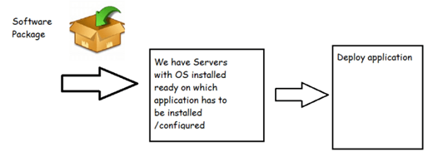

* Consider the following simple architecture 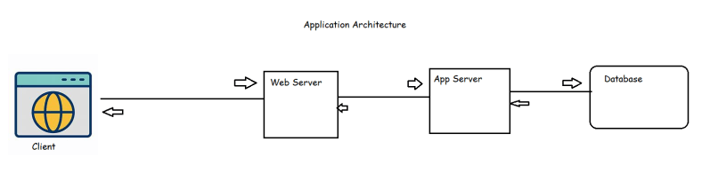
* Consider the following servers

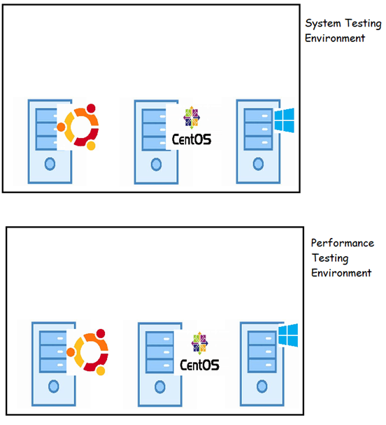

* To bring up our application,
  + We might need to install language frameworks
    - java
    - python
    - .net
  + We need to install server softwares
    - web server (apache/nginx)
    - app server (tomcat/websphere/jboss)
    - db server (mysql/postgres/SQL Server)
  + We need to deploy the software packages on necessary servers
  + We need to establish configuration for connectivity b/w servers
* Challenges:
  + In DevOps world we might need to setup environments almost every day
* We need to do the automation of application deployment and configuration and ensure it works on different environments
* Since we do deployments almost every day, we need to have automation giving us consistent results
* To automate these, we have scripting like shell/PowerShell scripting
* Disadvantages of shell scripting:
  + Readability & maintenance:
  + It has certain assumptions:
* We need some approach which helps in
  + writing readable scripts/configuration
  + Execution always gives us same results.

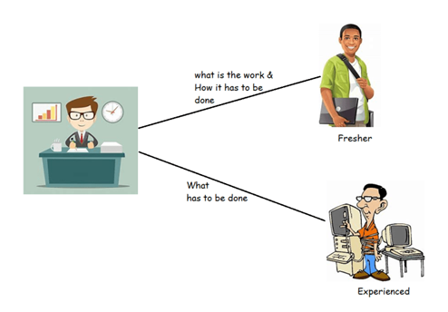

Let’s use plain English approach to understand this

| **Shell Script** | **Configuration Management** |
| --- | --- |
| use touch command to create a file 1.txt | Ensure file 1.txt is present |
| use apt to install apache server by executing  apt install apache2 -y | Ensure apache2 is installed |

* Configuration Management is a process for maintaining computer systems, servers and software’s in a desired, consistent state.

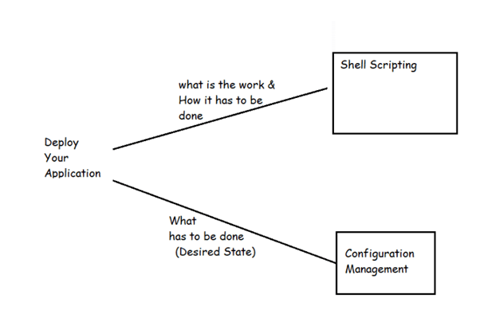

* This way ensures system performs as its expected to changes made over time
* PULL and PUSH BASED CM 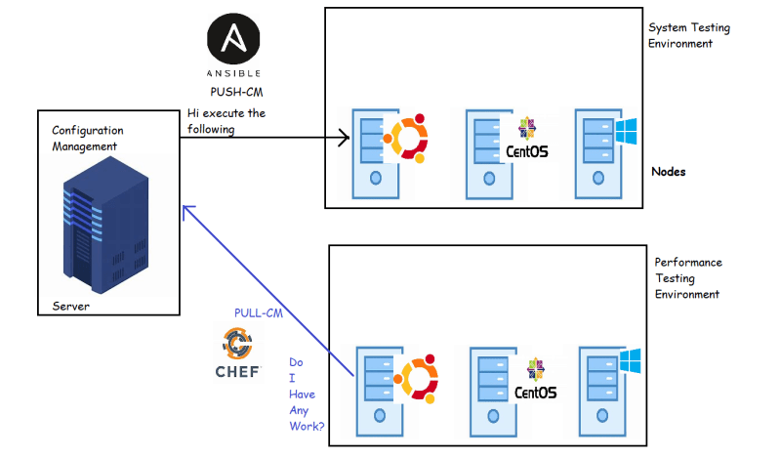
* In PUSH based CM Server needs to have information of list of nodes to communicate
* IN PULL based CM Nodes need to have software agent installed.

Note: Earlier, we are maintaining multiple static environments, and we are doing deployment to them manually. Now these days we are moving to cloud, and in cloud payment is pay per use, so depending on requirement we build and destroy system.